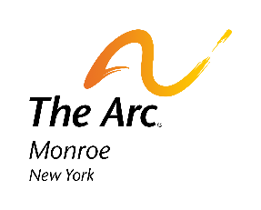

Job Description, February 2024

DSP-In-Training: PAID DSP Training Program

Are you looking for a new career path? Are you a responsible, caring, and dedicated person looking to make a difference in the lives of others? Then we have the perfect opportunity for you. We will train you to become a Direct Support Professional (DSP). In this role you will work directly with adults with intellectual and developmental disabilities in a residential setting to provide person centered support; promoting confidentiality, privacy, human dignity, uniqueness, and physical and emotional well-being while supporting the individual to lead a self-directed life. Support people to develop and maintain relationships, advocate for justice, fairness and equity and full community participation. A DSP shows respect, integrity, and responsibility for the individuals they support, other staff members and the community they work in.
This FREE training program is a five week-long commitment and is comprised of both classroom instruction and hands-on clinical experiences. Training will be 30 hours per week, Monday-Thursday & Fridays will be scheduled based on shadowing. You will be hired as a DSP Trainee and will receive 17.00/hour to support you while you’re training. After successful completion, trainees will be assigned a full-time position as a DSP in our Residential or Day Habilitation programs and your salary will increase to $17.00 to $19.00, depending on your location.
Qualifications:
- High school diploma or equivalent.
- Valid New York state driver’s license.
- Excellent communication skills.
- No prior experience is required due to the training program we would provide.
- Must be caring, compassionate and empathetic.
- Mus be willing to learn and apply new skills.
- Must be dependable, team player and empowering.

For more information or to apply, please contact:

Kateri Whirtley
(she/her/hers)
Talent Acquisition Coordinator
Human Resources
The Arc of Monroe
2060 Brighton Henrietta Townline Road
Rochester, NY 14623
Phone: 585-271-0660 x 2575
Fax: 585-271-7950

