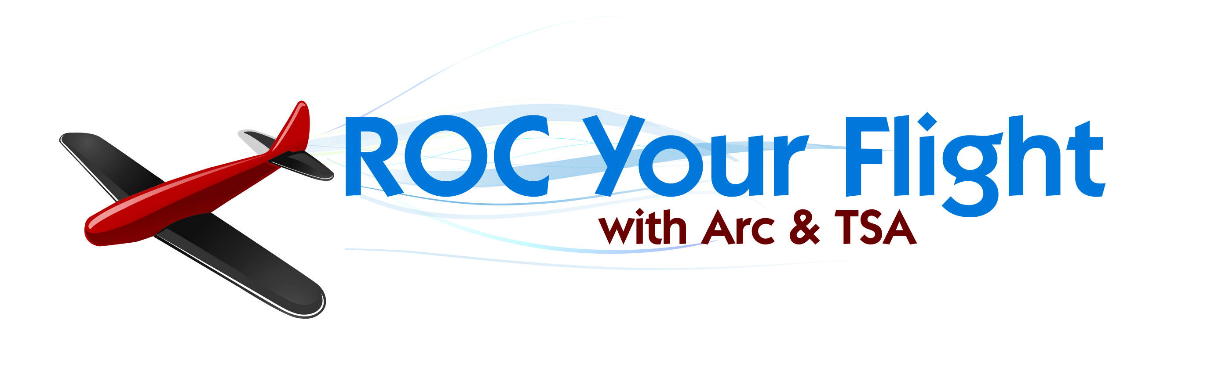

The Arc of Monroe has teamed up with the Frederick Douglass Greater Rochester International Airport and TSA to bring to you **ROC Your Flight**!

Roc Your Flight is a travel training program open to community members who would like to gain some experience with the process of flying. This program gives participants an opportunity to become familiar and confident with air travel. This training is held on a Thursday evening, when participants are given an introduction to the security and boarding process, undergo passenger security screening at the TSA checkpoint, are able to board a commercial aircraft and (if available).

We are proud to offer the next training session on:

**Thursday, June 27th, 2024 at 4:30 pm**

To register, please complete the attached information sheet and photo release. Program time is approximately 1.5 hours. Once we receive your completed application and photo release, we will send you an information packet to prepare you for the training.

Questions about the program?

Contact Matt Fico at (585)672-2222 or [mfico@arcmonroe.org](mailto:mfico@arcmonroe.org)

**Roc Your Flight Information Sheet**

(PLEASE PRINT)  
Session you wish to attend (*please pick one*)  
**☐ June 27th, 2024**

Name:   
(*as it appears on your valid government issued identification*)  
Address:   
City, State, Zip:   
Phone: Email:   
Birthdate: ☐MALE ☐ FEMALE

If you are over the age of 18, do you have a valid government issued photo identification that has not expired? ☐Yes ☐No

**PLEASE CHECK ANY ACCOMMODATIONS THAT APPLY TO YOU:**

☐Wheelchair

☐Aisle chair required

☐Personal manual wheelchair

☐Onboard wheelchair assistance

☐Walker/Cane ☐Blind/Visually Impaired

☐Deaf/Hard of Hearing

☐Need a Sign language Interpreter

☐Traveling with a service animal

☐Traveling with a mobility or other assistive device (please specify) ______________________

Do you have any concerns that we need to be aware of (in regards to the airport experience)?

____________________________________________________________________________­­­­­­­___

______

Do you receive services from The Arc? ☐Yes ☐No   
If no, do you receive services from any other agency? ☐Yes ☐No   
If yes, which agency?

Full name of all that are attending with you as it appears on their government issued identification:

Name: __ Birthdate:   
Name: __ Birthdate: ___   
Name: __ Birthdate:   
  
Thank you! We will send you a training information packet and more details about parking and directions to the airport meeting room a few days before the session date. **FORMS NEED TO BE SUBMITTED 1 WEEK PRIOR TO THE TRAINING DATE. PLEASE SEND TO:**

**THE ARC OF MONROE COUNTY**

**ATTN: Matt Fico**

**2060 BRIGHTON-HENRIETTA TOWNLINE ROAD ROCHESTER, NY 14623**

**Or scan and Email to:** [**mfico@arcmonroe.org**](mailto:mfico@arcmonroe.org)