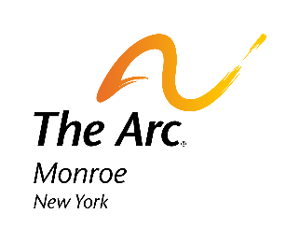

14(c) Position Statement – The Arc of Monroe

The Arc of Monroe strongly opposes the proposed elimination of section 14(c) of the Fair Labor Standards Act, which would severely limit choice and opportunities for New Yorkers with disabilities.

As Congress considers legislative proposals for supporting individuals with intellectual and developmental disabilities, it must remember that there will be employees working under 14(c) who will struggle with a transition, even with support, and will be unable to successfully access and maintain competitive employment. Currently, all employees earning subminimum wage in New York state work in a competitive integrated business, not a “sheltered workshop.” Their workday is spent working alongside people with and without disabilities, fostering their self-worth, social skills, and life enrichment—benefits that extend far beyond financial compensation. Removing Section 14(c) would reduce job opportunities and diversity for those who rely on these services. Section 14(c) creates an essential avenue for individuals to gain meaningful employment while earning subminimum wages based on their productivity.

The repeal of Section 14(c) would lead to higher unemployment rates among individuals with disabilities, increase support costs, and diminish their choices. Many depend on this framework to achieve fulfillment and independence, bridging the gap between day habilitation and supported employment. The narrative that individuals can easily transition to alternative employment overlooks the realities of those affected. For many, the loss of 14(c) would strip away not only their jobs but also vital benefits, potentially pushing them into undercompensated or volunteer opportunities that do not meet their needs or aspirations. The Arc of Monroe is dedicated to preserving the choice and dignity of individuals with disabilities. We firmly oppose the phaseout of Section 14(c), as it threatens the foundational employment opportunities that enable meaningful lives and fulfillment.

